Executive Summary
On June 20, 2016, the Division of Purchase and Property announced the official premiere of NJSTART, the State of New Jersey’s new eProcurement solution at www.NJSTART.gov. NJSTART (New Jersey State-of-the-Art Requisition Technology) has been highly successful in attracting new vendors with more than 13,000 suppliers already registered and eager to use the State’s new user-friendly Vendor Portal. This unique portal was designed to make it easier for suppliers to do business with the State by consolidating all procurement activities into a one-stop-shop.
Standout features of the Vendor Portal provided to resolve vendor feedback include: (1) a Vendor Library (an online repository for vendor forms, now eliminating the need to prepare forms repeatedly); (2) vendors can now see a snapshot of the certifications required to do business with the State along with their status; (3) small and disadvantaged businesses now have a directory to network to pursue more opportunities; (4) vendors can now manage their financial profile and even select their preferred form of payment; and (5) vendors can now take corrective action through the portal to ensure their profile is in good standing.
To enhance this one-stop-shop, the Division revamped its existing website to include a prominent Vendor Support page featuring various online resources such as Vendor Reference Guides, videos, and the Division now provides real time Vendor Support. A comprehensive communications campaign that included print and digital advertising was launched to announce the opportunities of the Vendor Portal. Please see Appendix A for screenshots of our NJSTART Registration Video, which can be viewed in its entirety at http://www.state.nj.us/treasury/purchase/njstart/vendor.shtml.
This initiative is a result of direct feedback solicited from suppliers who overwhelmingly complained about the excessive steps required to do business with the State. Multiple hurdles plagued the entire procurement lifecycle – from onerous procedures required at bidding to issues with receiving payment once a contract was finally awarded. Beyond the regulatory issues, the vendor, using agencies and the Division were desperate for an efficient user-friendly procurement system.
With this framework, the Division conducted an internal review of its policies, use cases and work flows. At the core of this review’s findings was the need to move from the State’s transactional legacy mainframe application and a variety of other disparate supporting systems, to a modern single solution. So it was with this in mind that the Division awarded a contract for the State’s new solution. The implementation of the system involved the integration of multiple State procurement, regulatory and financial processes required to do business with the State. The State is retiring four of its major legacy systems and integrating several others, resulting in substantial cost savings.
NJSTART provides an efficient and consolidated process for State agencies to conduct business and modernizes the way that services and commodities are procured. Although the underlying procurement application is in use in a few other states, New Jersey is leading the way with a fully integrated Vendor Portal solution.

Innovation and Initiative
The new Vendor Portal at www.NJSTART.gov streamlines the procurement process and makes it more efficient for both the State as well as businesses seeking a contract with the State. Specifically, the Vendor Portal provides vendors with a complete Library to set up profiles and upload documents, which eliminates the need to file duplicate forms every time they bid on a new contract solicitation.
Other key features of the Vendor Portal: vendors can now see a snapshot of the certifications required to do business with the State along with their status; small and disadvantaged businesses now have a directory to network; vendors can now manage their financial profile; and take corrective action.
Moreover, the Vendor Portal is designed to offer vendors an online “one-stop-shop” from bid opportunity notification to the submission and tracking of quotes, certifications, contract awards, and payments (see Appendix B). NJSTART allows vendors to access training manuals and reference guides online. The new system is very user friendly and increases the transparency of the process.
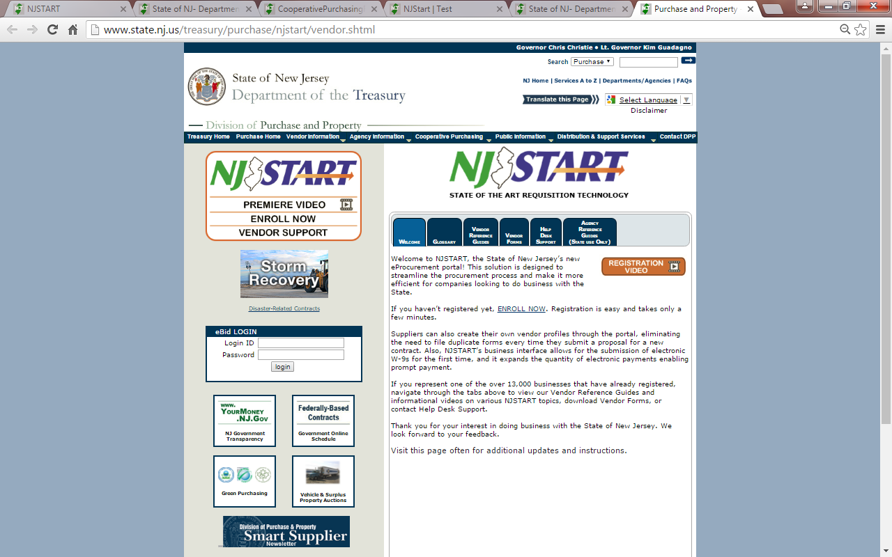
NJSTART’s public search engine allows agencies and other government entities to access more vendors, thereby increasing competition and decreasing contract prices.
The State has integrated its financial, procurement, and tax/revenue systems, and our Office of Management & Budget (OMB) has re-engineered its W-9 and address change processes, eliminating the need for paper copies and reducing processing time by OMB staff. We have also expanded the quantity of EFT/ACH payments reducing paper checks and expediting the payment process for suppliers.
The response from the vendor community has been extremely positive. To date, our State Vendor Administrators have supported thousands of registered vendors through the NJSTART support line and email box to assist them with various issues from registration to maintenance of their NJSTART profiles. In our first week, a vendor wrote, “Thank you! It was a pleasure dealing with you which restored my confidence in NJ State customer service!!” Many such comments have been followed.

Transferability
This solution can be used by any other state or agency. It proves that a State’s procurement process can be combined into one brick-front solution. NJSTART’s Vendor Portal would be beneficial to any state looking to improve their eProcurement process and is universal in terms of its usage. The underlying application is in use in a few other states and is available for purchase as a configurable Software as a Service (SaaS) product. New Jersey will make itself available to our fellow NASPO members to guide them to design their own Vendor Portal.
Service Improvement
The Division is a critical contributor to the Department of the Treasury in managing the State budget. The Division understands that competition is the single most effective way to lower contract pricing. In order to get to a price competition, we must have responsive proposals that comport with an intricate regulatory framework. While this Vendor Portal is lauded by the business community for its ease of use and transparency, ultimately it is its ability to attract vendors to do business with the State that that offers its greatest benefit to our penultimate constituent – the taxpayer.
The second largest constituency to benefit from the Vendor Portal are our Using Agencies that perform simple procurements and use our contracts by issuing orders. An example of the service benefit to the Using Agencies is that NJSTART was designed to block payment if a vendor was to lose its business registration status. This is not only good government but it also protects the Using Agencies’ funds.
Additional benefits touted by our client Agencies are their brand new ability to access and review entire vendor records and forms online in the Vendor Library instead of waiting on answers through a manual process from different program units. They are also very excited that they can for the first time track procurement, orders and payments through NJSTART approval paths. A last example of the many benefits is that due to the integration of the State’s financial, procurement, and tax/revenue systems, vendors can now certify their W-9s electronically, eliminating the need for paper copies and reducing processing time by State staff.
Cost Reduction
The implementation of NJSTART will reduce the State’s costs significantly, decreasing from approximately $1.2 million per year, to $875,000. The savings generated over the lifetime of the NJSTART project will nearly cover the implementation costs of a modern one-stop-shop solution, instead of maintaining numerous antiquated, disparate systems.
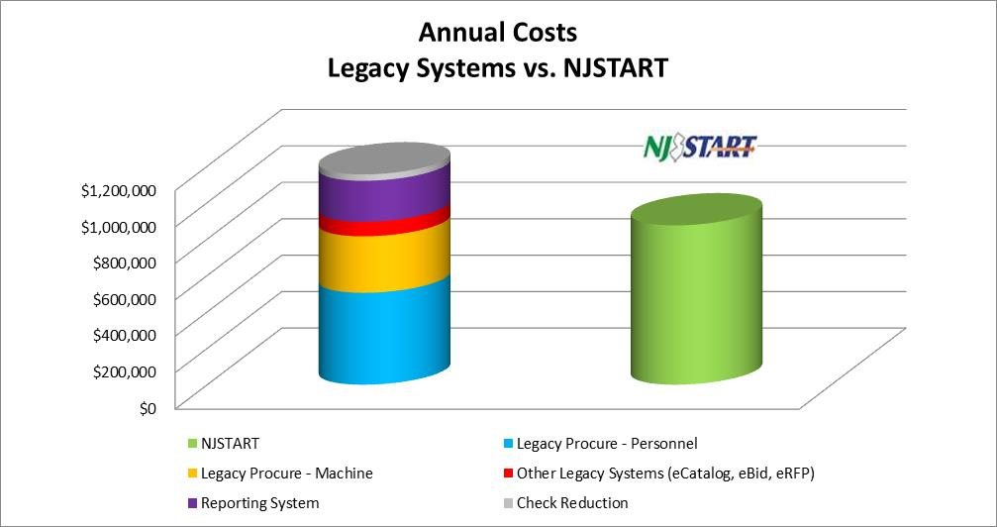
The State is retiring four of its major legacy systems: Legacy Procure, MACSE – Management Acquisition Control System; eBid – electronic bidding; eRFP – electronic notification service; and eCatalog – electronic transactional contract shopping, resulting in savings of nearly $900,000 annually.
Utilizing NJSTART’s more robust reporting functionality, the State is saving another $225,000 annually by ending a contract with a previous supplier. Also, vendors can enter their banking account information directly into their NJSTART profile enabling the State to expand the quantity of EFT/ACH payments it makes. The State expects to save another $35,000 annually by reducing the quantity of paper checks it has to print and mail. Other preventative savings such as inappropriate payment of taxpayer funds now being automatically protected and increased productivity throughout the State on thousands of programs cannot be estimated at this time.
Conclusion
The Division of Purchase and Property premiered NJSTART on June 20, 2016 and is now administering all new bidding opportunities through the new solution. NJSTART’s Vendor Portal has been hugely successful in attracting more than 13,000 vendors to conduct State business.
NJSTART is designed to increase competition and open up the procurement process for small companies as well as large ones. Increased competition not only saves money for New Jersey taxpayers, it also opens doors for companies that may have been shut out of the procurement process in the past because it seemed too complicated.
The Vendor Portal at www.NJSTART.gov is a state-of-the-art solution that is accessible by all State agencies as well as local governments. Suppliers can create their own vendor profiles through the Vendor Portal, eliminating the need to file duplicate forms every time they submit a proposal.
This solution enhances the visibility of small- , minority- and veteran-owned businesses so they can gain exposure to additional contracting opportunities. It also offers a ‘one-stop-shop’ for vendor management and allows suppliers to track submitted proposals, certifications, and contracts.
State agencies seeking to procure goods or services have access to all registered vendors through NJSTART. Suppliers are able to add multiple user accounts to the same profile so more than one person can work on a proposal.
Finally, the launch and implementation of NJSTART follows through on and supports the New Jersey Red Tape Review Commission’s recommendations to unify and streamline procurement and financial procedures. NJSTART improves intragovernmental efficiencies, streamlines the delivery of government services to the taxpayer, and plays a key role in our State’s great effort to make New Jersey a more attractive place to do business.

